3rd July 2014

Dear Parent/Carer

I have now been in post as Head Teacher at Peterhead Academy for 4 weeks and during that time, I have been overwhelmed at the support from the staff, parents and the wider community. At this time of year, there are numerous events where I have had the opportunity to meet with parents and staff across the Peterhead Cluster and I am confident that we can all work together to continually strive to deliver the best possible learning experiences for the young people of the town.

The pupils have been extremely welcoming and helpful as they see me lost in the maze of corridors.

I want to highlight some of the achievements of the term as well as inform you of a few changes that will be made for the start of the next session:

**Achievements/Trips:**

**S2 Bake Off:** All S2 pupils created a shortbread biscuit incorporating ingredients from across the Commonwealth. The winning teams took part in the Great Commonwealth Bake Off on the 22nd May where they delivered presentations and their biscuits were sampled. The winning team was Tribal Warriors who won with their creation named Bananey Pyramids. This was an excellent enterprising opportunity that allowed pupils to research into food products across the Commonwealth nations.

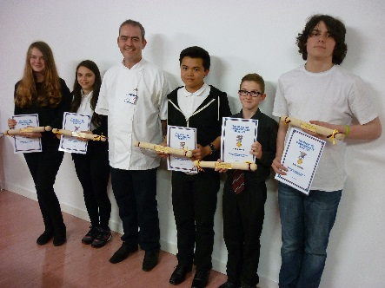

**Our Very Own Novelist:** Well done to Estelle Maskame who has written 3 novels which have grasped the interest of readers and the press alike. She was interviewed by STV and the Press and Journal this term to highlight her talents. This is a fantastic achievement for Estelle and we can see a very successful career for her in this field in the future.

**Young Engineers**:

Our Young Engineers competed in the Scottish Greenpower Heats where their teamwork skills were highlighted. They have since displayed their design at the Parent Council summer fete and at the P7 Parents’ Information Evening.

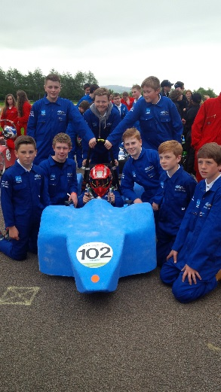

**Rock Challenge:**

Rock Challenge headed off for the Northern Premier Finals on the 13th June. They won various individual rewards including Most Entertaining Performance and Best Stage Crew. The theme this year was ‘Taken’ and the work and effort made in the background was evident through a clean and polished performance.

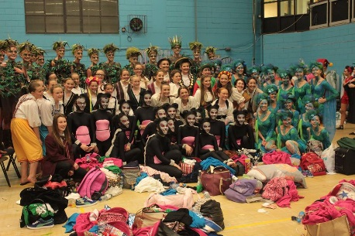

**Young Enterprise - Candolls**:

The Young Enterprise programme has enabled 7 S5/6 pupils to develop their team skills and work to tight deadlines.  They have been able to transfer their business knowledge into real life experiences. Pupils attended various seminars in Aberdeen and traded at the Christmas Fayre in the Bon Accord Centre, winning the Best Sales and Marketing Award and also traded at various school events. The pupils reached the Grampian Finals and were awarded the prize for Best Presented Team They have also successfully passed the Strathclyde University Business Exam.

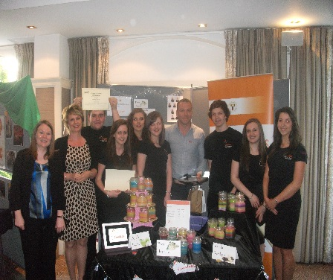

**S3 Biology Field Trip – Aden Park:**

On the 12th and 19th of May, S3 biology pupils were given the opportunity to practice their sampling techniques in the grounds of Aden Park. The main focus of the trip was to study pollution levels in the River Ugie using freshwater invertebrates, undertaking a line transect and sampling organisms from a broad leaved and a coniferous tree. All 85 pupils thoroughly enjoyed the field trip and their behaviour was a real credit to the community.

**Art Project:**

A number of S3 pupils produced images that have been digitised in collaboration with Aberdeenshire Council and have been displayed along a fence on West Road. The images have a sporting theme in order to help celebrate the Queen’s Baton Relay on the 29th June.



**Duke of Edinburgh Awards:**

Yet again, we have a large number of participants in the Duke of Edinburgh Award Scheme doing bronze, silver and gold awards.

The programme will continue throughout 2014/5 with the new third years beginning their bronze award early in 2015.

**Cluster Choir Festival:**

The Peterhead Academy Junior Choir took part in the very first “Peterhead Schools Festival of Choirs” at the Peterhead Old Parish Church. The festival saw 7 primary schools along with pupils from the academy join together and sing in a mass choir of over 200 hundred voices as well as perform a 10 minute programme unique to each school choir. Every choir performed to packed audiences over two evenings.

**‘Survival’ Concert:**

6th year pupil Sianan Watson was invited to open the return of a highly successful concert ‘Survival’ at the Beach Ballroom in Aberdeen at the end of May. “Survival” director MC aka Millennium Child heard Sianan sing at Peterhead Academy in a recent Scottish Arts initiative “Creative Edge” visit and was impressed by her vocal skills. Sianan took to the stage and sung a beautiful rendition of “Autumn Leaves”, originally sung by Eva Cassidy, to a full and appreciative audience.

The Survival concert brings different groups, children & young people together to share in their passion for performing arts. Money raised from the concert is donated to Aberdeen Neo-Natal intensive care unit, Children In Need, Help for Heroes, Archie Foundation and Cash for Kids.



**Petrochallenge:**

Towards the end of June, 10 Peterhead Academy senior students attended Robert Gordon University to take part in Petrochallenge – a UK-wide oil and gas simulation competition for schools and colleges. The teams had to act as an oil company analysing, researching, bidding for plots of land, drilling for oil and gas, and negotiating with other teams to buy and sell shares of their companies. The Peterheid Petroheids won the competition, the first time a team from the Academy has done this and may be asked to London to take part in the final.

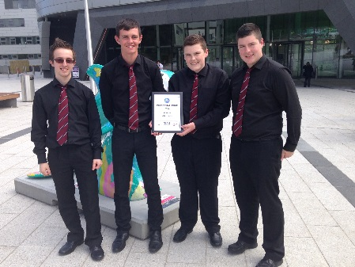

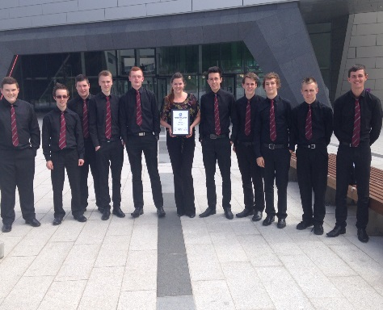

**Activities Days:**  
This year more than 600 of our pupils took part in a range of activities that stretched their physical strength and their imagination. Trips to London, Alton Towers, Inverness, Landmark at Carrbridge and Bedlam Paintballing at Edzell were all a success. Trips nearer to home also took place.  
There were a number of activities from physical to creative within school and pupils participated eagerly.   
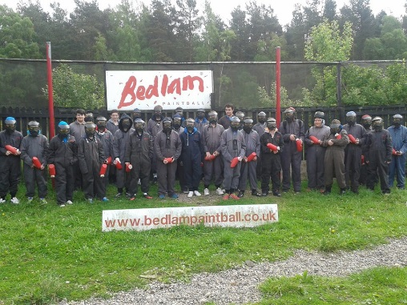

**France trip:**

**Modern Languages** ran another successful trip to France this term. They spent 3 days in an activity centre where they used their French in some real life situations - ordering food at a French market and to follow a town trail in Mayenne. Pupils shopped in a local “SuperU”, tried snails (delicious?) and built their own campfire one evening. They made a visit to the monastery at Mont St Michel and the towns of Fougères and St Malo.

Day 4 was Paris where they went on a boat trip down the Seine followed by an ascent up to the top of the Montparnasse tower. The final day was spent in Disneyland before the long trek home.

Pupils on the trip were commended by staff at the activity centre for their good behaviour and excellent participation levels with the bus driver saying they were the best school he had ever taken on a trip! Well done to all pupils concerned!

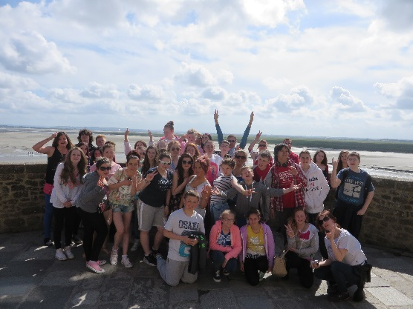

**Commonwealth Games**

S3 hospitality pupils hosted a Soup and Sweet event for all the academy staff.  To tie in with the forthcoming Commonwealth Games, they incorporated tastes from around the Commonwealth.  Pupils planned the event, sold tickets and then spent the day making and serving their food.  Many of the staff commented on the high standard of fare received on the day.

S2 pupils made Commonwealth flags as part of their textile unit.  These flags were displayed at the Queen’s Baton Relay on Sunday 29th June.

**Summer Fete:**

The Parent Council held a Summer Fete with the help of pupils and staff at the school. On Friday the 20th June members of the Parent Council spent the day in the Home Economics kitchen preparing homebakes for sale at the Summer Fete. Under the watchful eye of Mrs Hood and the Baking Club they creamed, whisked and decorated an array of treats for sale. Their efforts helped raise over £300 on the day. Baking Club will continue after the holidays on Thursday from 3-4.15pm.

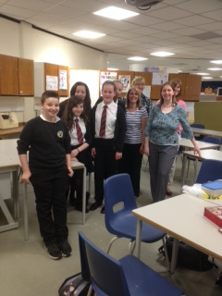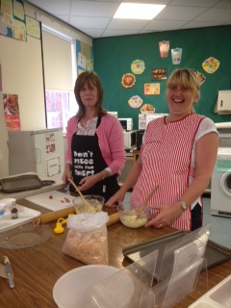 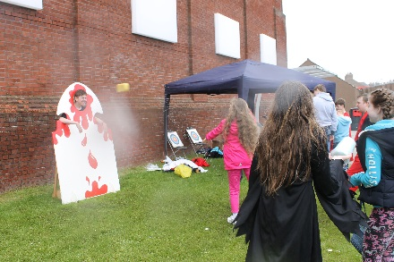

**Swimming Success:**

Well Done to Caitlin Davies for making it to the Finals of the Scottish National Age Group Championships on Friday 27th June and doing her 50m Free in 28.34s. According to reports this now ranks her (for 50m Free) No.5 Nationally and No.3 in Scotland for 14 years old girls. This is a fantastic achievement.

**School Show:**

The school show, Sunset Song, was well supported by family and the community this year. It is a hard hitting piece of work and pupils delivered an excellent performance on both nights, having to pull on their acting skills to draw the audience into the story. Thanks must also go to the staff at the school for the endless hours they offered in order to deliver the production as well as those that came to support the pupils.

**Information for Next Session:**

**SQA:**

Senior pupils were given a letter to take home regarding the change in SQA procedures where there are no longer appeals. Instead, a re-mark or clerical check can be requested and will only be granted by the school if there is evidence that they have underperformed compared to their assessments and work completed throughout their course. The re-mark can result in grades staying the same or can be increased or decreased.

During the holidays, messages from concerned parents will be taken but will be dealt with by the SQA Coordinator on the first days of the new term.

**Attendance/Appearance/Attitude/Attainment:**

I have made no secret that, whilst impressed with the wider achievement of our young people at Peterhead Academy, there is plenty of work to be done with regard to exam results. The new tracking and monitoring system already in place will help to alert parents and pupils at an early stage that there are problem areas to allow time for our youngsters to address difficulties and progress in their courses. I firmly believe, however, that attainment is also intrinsically linked to appearance, attitude and attendance. School Uniform has been hugely successful and I urge you, as parents/carers to continue to support this. It creates a sense of belonging as well as attitude towards work being more positive when pupils are smartly dressed.

I have spoken to pupils at assemblies and have made very clear to them that attendance and attitude are also key. We want to ensure that pupils attend all of their timetabled classes, that they arrive for their classes on time, that their behaviour is appropriate and that they have at least 85% attendance. This attendance figure is the equivalent of 1½ days off out of every 10 school days which would still seriously impact on their learning and so I would expect that this would be much higher for the vast majority of youngsters in the school. Attendance will be very closely monitored from August 2014 in order to fulfil our Child Protection requirements as well as being part of our raising attainment strategy. Please contact the school at the earliest possible convenience if your child has a legitimate absence to allow us to code the absence appropriately.

If pupils do not reach any or some of these parameters, then they will be withdrawn from any of their wider school activities. This will include school clubs, representing their school in sport or Rock Challenge and attending whole school events such as University days or Prom. We need pupils to understand that passing curricular courses has to be their first priority and that their wider achievements are in addition to rather than an alternative to their qualifications. I trust that you will fully support this in order to see our youngsters leave school with the qualifications they need in order to choose their continued pathway rather than restrict it.

**Staffing:**

Education has had to take a serious reduction in budget since the economic downturn and this continues to be an issue. We therefore have to prioritise which school trips can run, partly because of funding and also because of the impact this has on Learning and Teaching when staff are out of school. We will try to continue to run the trips that have the most positive impact on pupil learning but finance has to be a consideration.

Due to the drop in school roll and a reduction in any additional posts we were granted, we have lost a Guidance Teacher as well as losing 1.4 Depute Head Teacher posts. Some areas of the curriculum are very tight and so a number of Deputes Head Teachers also have a considerable teaching commitment. For these reasons, can I ask that, if you want to speak to a member of staff, you call to make an appointment first as there is not always someone available to speak with you immediately. Your first point of contact should always be Guidance who can then coordinate and speak to the staff that may be able to help with the particular issue concerned. This will avoid any disappointment by turning up to school to find that no one is available at the time.



**Dates for your Diary:**

**Tuesday 5th August:** SQA Examination results

**Tuesday 19th August :** Pupils return for new session

**Thursday 28th and Friday 29th August :** S1 Baseline

Assessments

**Monday 22nd and Tuesday 23rd September:** School Photos

**Friday 10th October:** end of term

**More details of the above events will be available in due course**

Further school information can be found in our school website: [**www.peterheadacademy.aberdeenshire.sch.uk**](http://www.peterheadacademy.aberdeenshire.sch.uk)

Thank you for your continued support over this session and I look forward to working with you in the coming session to continue to make improvements. We, as a school, are very keen to work with you as parents/carers and so we value what you have to say. Please continue to use our school e-mail to highlight any issues you may have.

I wish you a very pleasant summer holiday.

Yours faithfully

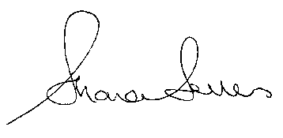

**Shona Sellers**

**Head Teacher**